{"requestType":"view\_blockchain\_status"}



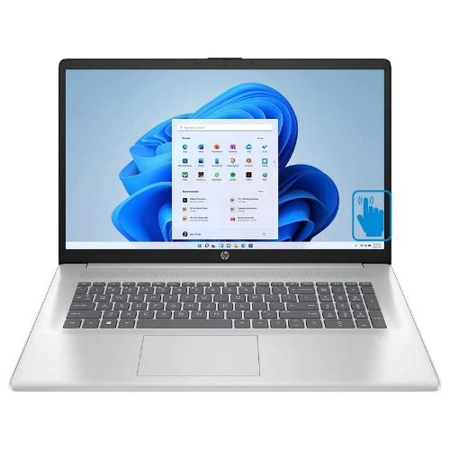

[HP 17-cp2035cl 17.3" HD+ Touch Laptop AMD Ryzen 3 7320U 8GB RAM 512GB SSD W11H](https://www.ebay.com/itm/375971636065?_trkparms=amclksrc%3DITM%26aid%3D777008%26algo%3DPERSONAL.TOPIC%26ao%3D1%26asc%3D20240603121456%26meid%3D35b57e1ad0484dc793eaa7af1eaa3d84%26pid%3D102177%26rk%3D1%26rkt%3D1%26itm%3D375971636065%26pmt%3D1%26noa%3D1%26pg%3D4375194%26algv%3DNoSignalMostWatched%26brand%3DHP&_trksid=p4375194.c102177.m166540&_trkparms=parentrq%3A96a7d9ce1950ad91999a50b5ffffe962%7Cpageci%3A103ccf67-011f-11f0-8775-befb4ed97ae3%7Ciid%3A1%7Cvlpname%3Avlp_homepage" \t "_blank)

**[$269.00](https://www.ebay.com/itm/375971636065?_trkparms=amclksrc%3DITM%26aid%3D777008%26algo%3DPERSONAL.TOPIC%26ao%3D1%26asc%3D20240603121456%26meid%3D35b57e1ad0484dc793eaa7af1eaa3d84%26pid%3D102177%26rk%3D1%26rkt%3D1%26itm%3D375971636065%26pmt%3D1%26noa%3D1%26pg%3D4375194%26algv%3DNoSignalMostWatched%26brand%3DHP&_trksid=p4375194.c102177.m166540&_trkparms=parentrq%3A96a7d9ce1950ad91999a50b5ffffe962%7Cpageci%3A103ccf67-011f-11f0-8775-befb4ed97ae3%7Ciid%3A1%7Cvlpname%3Avlp_homepage" \t "_blank)**[$499.99](https://www.ebay.com/itm/375971636065?_trkparms=amclksrc%3DITM%26aid%3D777008%26algo%3DPERSONAL.TOPIC%26ao%3D1%26asc%3D20240603121456%26meid%3D35b57e1ad0484dc793eaa7af1eaa3d84%26pid%3D102177%26rk%3D1%26rkt%3D1%26itm%3D375971636065%26pmt%3D1%26noa%3D1%26pg%3D4375194%26algv%3DNoSignalMostWatched%26brand%3DHP&_trksid=p4375194.c102177.m166540&_trkparms=parentrq%3A96a7d9ce1950ad91999a50b5ffffe962%7Cpageci%3A103ccf67-011f-11f0-8775-befb4ed97ae3%7Ciid%3A1%7Cvlpname%3Avlp_homepage" \t "_blank)

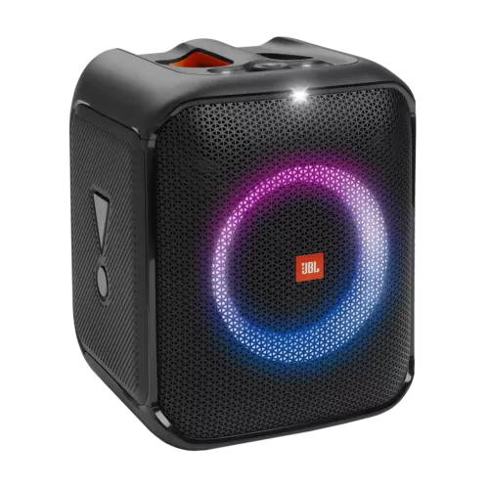

[JBL Partybox Encore Essential](https://www.ebay.com/itm/204761708018?_trkparms=amclksrc%3DITM%26aid%3D777008%26algo%3DPERSONAL.TOPIC%26ao%3D1%26asc%3D20240603121456%26meid%3D35b57e1ad0484dc793eaa7af1eaa3d84%26pid%3D102177%26rk%3D1%26rkt%3D1%26itm%3D204761708018%26pmt%3D1%26noa%3D1%26pg%3D4375194%26algv%3DNoSignalMostWatched%26brand%3DJBL&_trksid=p4375194.c102177.m166540&_trkparms=parentrq%3A96a7d9ce1950ad91999a50b5ffffe962%7Cpageci%3A103ccf67-011f-11f0-8775-befb4ed97ae3%7Ciid%3A1%7Cvlpname%3Avlp_homepage" \t "_blank)

**[$224.96](https://www.ebay.com/itm/204761708018?_trkparms=amclksrc%3DITM%26aid%3D777008%26algo%3DPERSONAL.TOPIC%26ao%3D1%26asc%3D20240603121456%26meid%3D35b57e1ad0484dc793eaa7af1eaa3d84%26pid%3D102177%26rk%3D1%26rkt%3D1%26itm%3D204761708018%26pmt%3D1%26noa%3D1%26pg%3D4375194%26algv%3DNoSignalMostWatched%26brand%3DJBL&_trksid=p4375194.c102177.m166540&_trkparms=parentrq%3A96a7d9ce1950ad91999a50b5ffffe962%7Cpageci%3A103ccf67-011f-11f0-8775-befb4ed97ae3%7Ciid%3A1%7Cvlpname%3Avlp_homepage" \t "_blank)**[$299.95](https://www.ebay.com/itm/204761708018?_trkparms=amclksrc%3DITM%26aid%3D777008%26algo%3DPERSONAL.TOPIC%26ao%3D1%26asc%3D20240603121456%26meid%3D35b57e1ad0484dc793eaa7af1eaa3d84%26pid%3D102177%26rk%3D1%26rkt%3D1%26itm%3D204761708018%26pmt%3D1%26noa%3D1%26pg%3D4375194%26algv%3DNoSignalMostWatched%26brand%3DJBL&_trksid=p4375194.c102177.m166540&_trkparms=parentrq%3A96a7d9ce1950ad91999a50b5ffffe962%7Cpageci%3A103ccf67-011f-11f0-8775-befb4ed97ae3%7Ciid%3A1%7Cvlpname%3Avlp_homepage" \t "_blank)

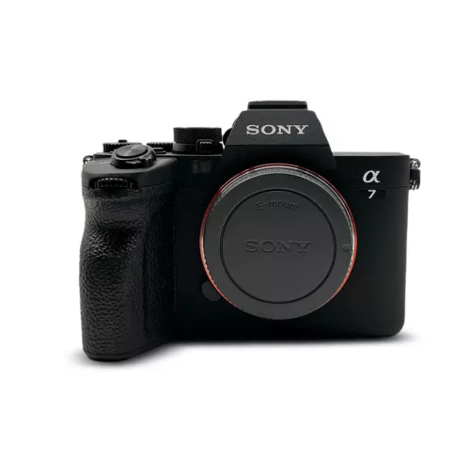

[Sony Alpha 7 IV Full-frame Mirrorless Interchangeable Lens Camera](https://www.ebay.com/itm/196159534406?_trkparms=amclksrc%3DITM%26aid%3D777008%26algo%3DPERSONAL.TOPIC%26ao%3D1%26asc%3D20231108131718%26meid%3Dbd8ae339f36a4c609d2c7668ff9b662b%26pid%3D101910%26rk%3D1%26rkt%3D1%26itm%3D196159534406%26pmt%3D0%26noa%3D1%26pg%3D4375194%26algv%3DFeaturedDealsV2&_trksid=p4375194.c101910.m150506&_trkparms=parentrq%3A96a7d9ce1950ad91999a50b5ffffe962%7Cpageci%3A103ccf67-011f-11f0-8775-befb4ed97ae3%7Ciid%3A1%7Cvlpname%3Avlp_homepage" \t "_blank)

**[$1,669.00](https://www.ebay.com/itm/196159534406?_trkparms=amclksrc%3DITM%26aid%3D777008%26algo%3DPERSONAL.TOPIC%26ao%3D1%26asc%3D20231108131718%26meid%3Dbd8ae339f36a4c609d2c7668ff9b662b%26pid%3D101910%26rk%3D1%26rkt%3D1%26itm%3D196159534406%26pmt%3D0%26noa%3D1%26pg%3D4375194%26algv%3DFeaturedDealsV2&_trksid=p4375194.c101910.m150506&_trkparms=parentrq%3A96a7d9ce1950ad91999a50b5ffffe962%7Cpageci%3A103ccf67-011f-11f0-8775-befb4ed97ae3%7Ciid%3A1%7Cvlpname%3Avlp_homepage" \t "_blank)**[$2,374.99](https://www.ebay.com/itm/196159534406?_trkparms=amclksrc%3DITM%26aid%3D777008%26algo%3DPERSONAL.TOPIC%26ao%3D1%26asc%3D20231108131718%26meid%3Dbd8ae339f36a4c609d2c7668ff9b662b%26pid%3D101910%26rk%3D1%26rkt%3D1%26itm%3D196159534406%26pmt%3D0%26noa%3D1%26pg%3D4375194%26algv%3DFeaturedDealsV2&_trksid=p4375194.c101910.m150506&_trkparms=parentrq%3A96a7d9ce1950ad91999a50b5ffffe962%7Cpageci%3A103ccf67-011f-11f0-8775-befb4ed97ae3%7Ciid%3A1%7Cvlpname%3Avlp_homepage" \t "_blank)

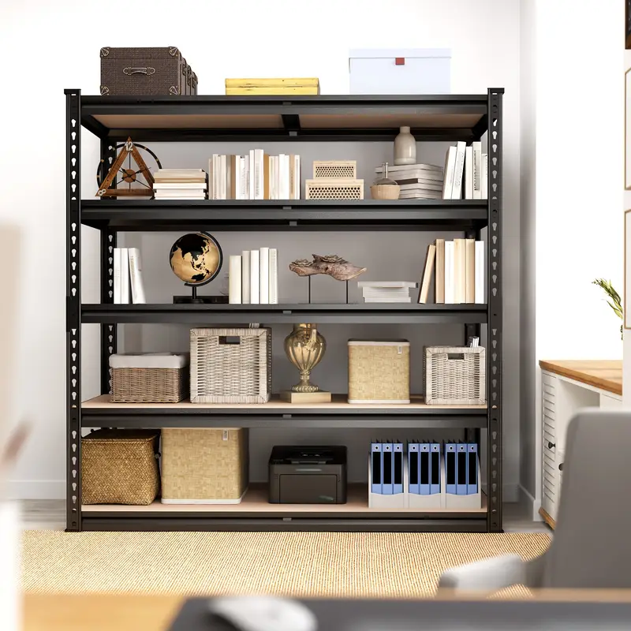

72" H Storage Shelves 2000LBS Garage Shelving Heavy Duty Shelving 5 Tier Metal Shelves for Garage Shelves 35.5"W X72"H X 15.8"D, Adjustable Shelving Unit for Basement Pantry Utility Rack Shelf, Office

$40.31

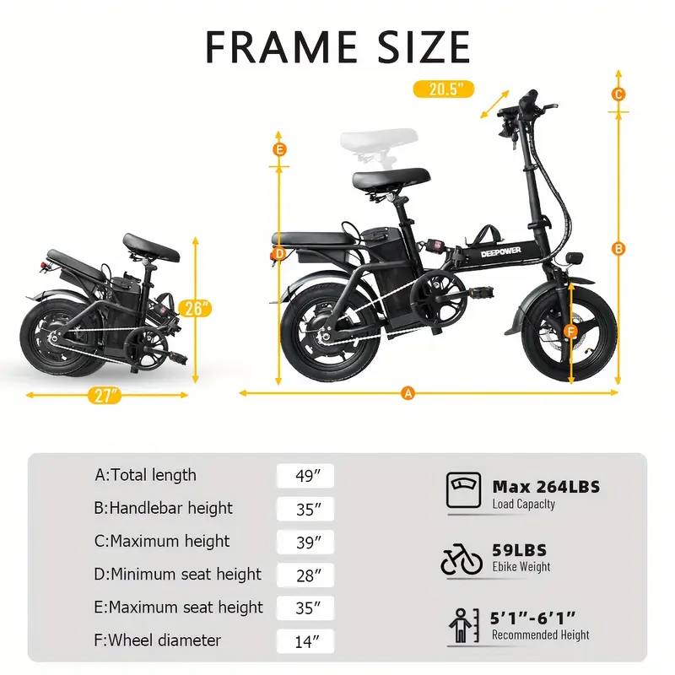

DEEPPOWER 400W Foldable Electric Bike for Adults, 20MPH Max Speed, 14" Tires, Removable 48V 10AH Battery, Multi-Shock Absorption, Left & Right Turn Signals, Water Bottle Holder, Basket, Black Retro Style, City Commuter E-Bike, Versatile Travel Bike | Sleek Black Design | Alloy Steel Wheels

$266.35

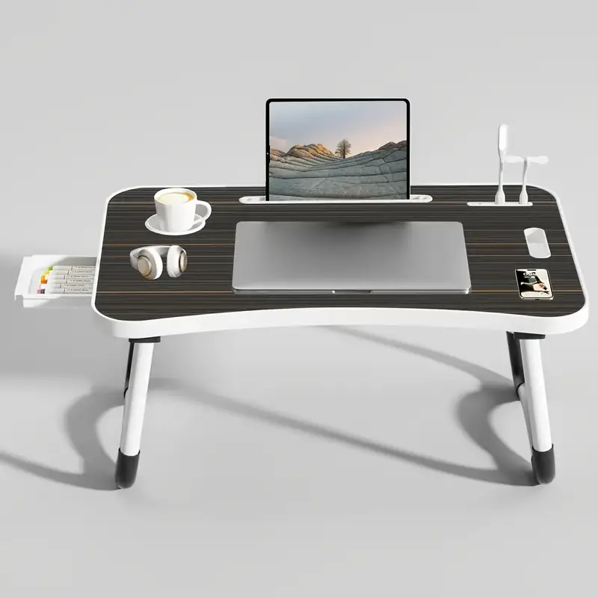

Extra Large Portable Laptop Bedside Folding Table, Computer Desk with Multi-Functional Tray Holder and Drawer – Includes USB Fan & Light – Ideal for RVs, Beds, Sofas, Floors, Dining, Reading & Writing – Stable, Durable & Foldable

$49.99

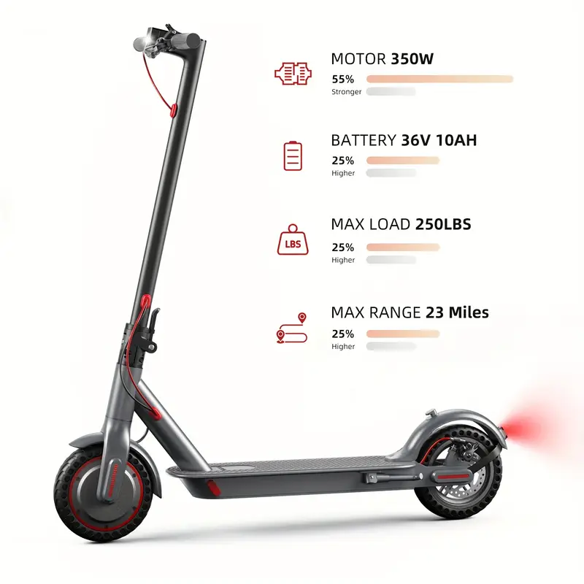

HT-T4 PRO 350W Foldable Electric Scooter for Adults & Teens, 23 Mile Range, 19MPH, 3 Speed Modes, LCD Display, Puncture-Resistant Tires, Headlight & Taillight, Zinc Alloy Frame - Perfect for Commuting, Campus, and Travel, Campus Transportation | Modern Electric Scooter | Robust Construction

$142.94

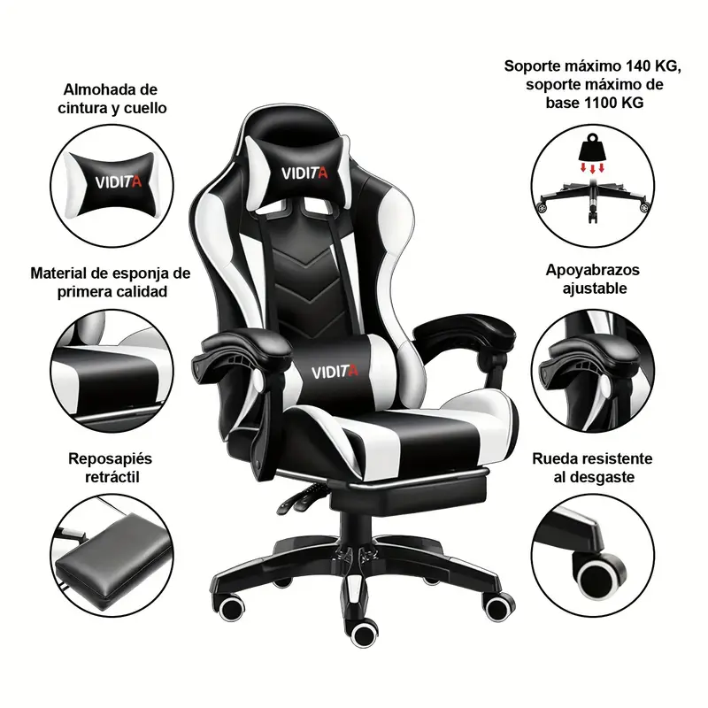

Ergonomic Gaming Chair for Adults & Teens: Racing Style PC Office Chair with Lumbar Support

$67.82

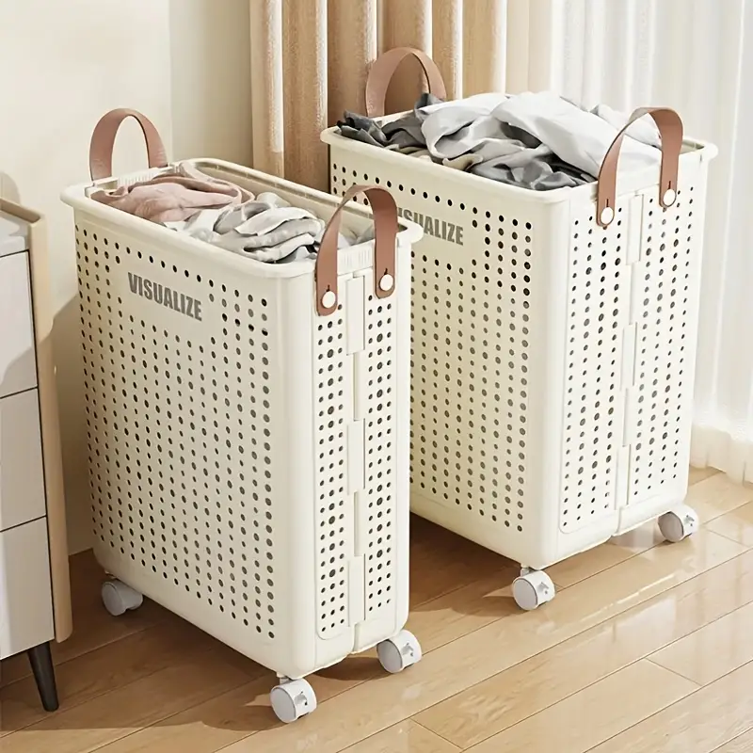

Foldable White Ceramic-Style Laundry Basket with Wheels – Large Capacity, Portable Dirty Clothes Hamper with Handles for Bathroom and Balcony Storage, Ventilated Design for Air Circulation, Laundry Room Accessories

$16.04

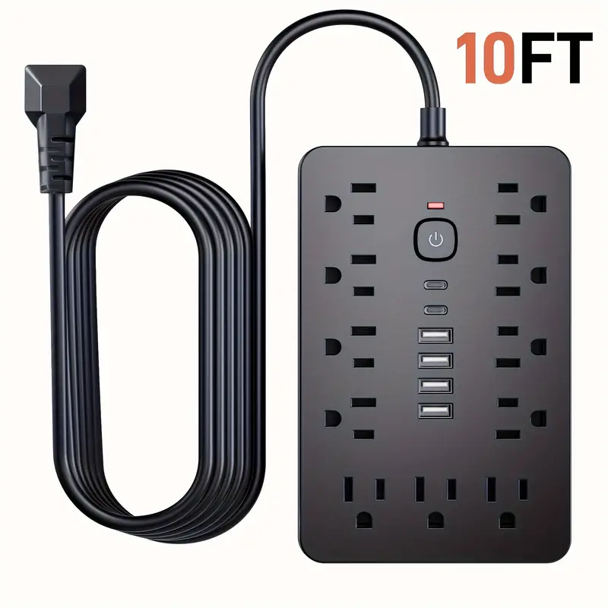

17-in-1 Surge Protector Power Strip with Switch, 11 US Outlets, 6 USB Ports (2 USB-C), 110V-130V, US Plug, 5/10ft - Ideal for Office, Kitchen, Dorm, Travel

$13.33

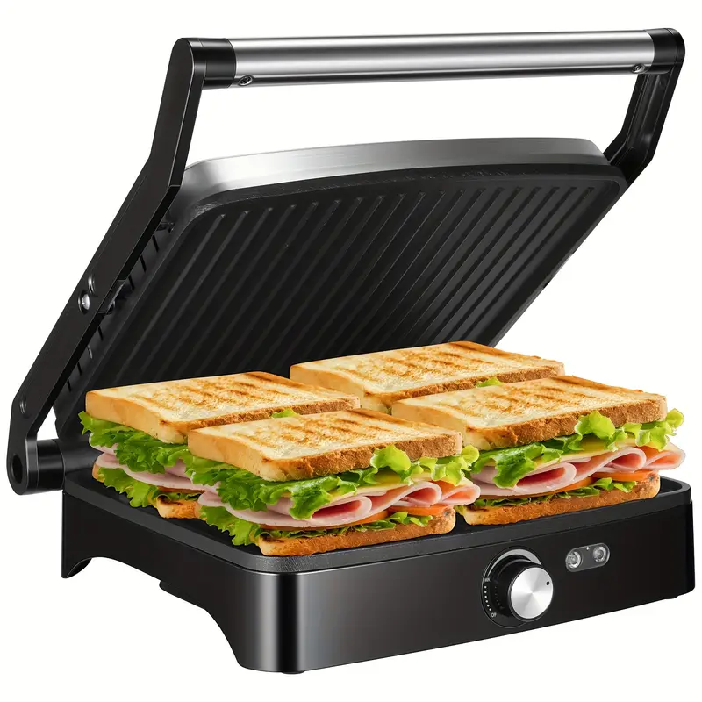

1200W Panini Press Grill & Sandwich Maker, 4-Slice Non-Stick Versatile Grill With Temperature Control, 180° Opening For Larger Foods, Removable Drip Tray, Indoor Use

$23.96

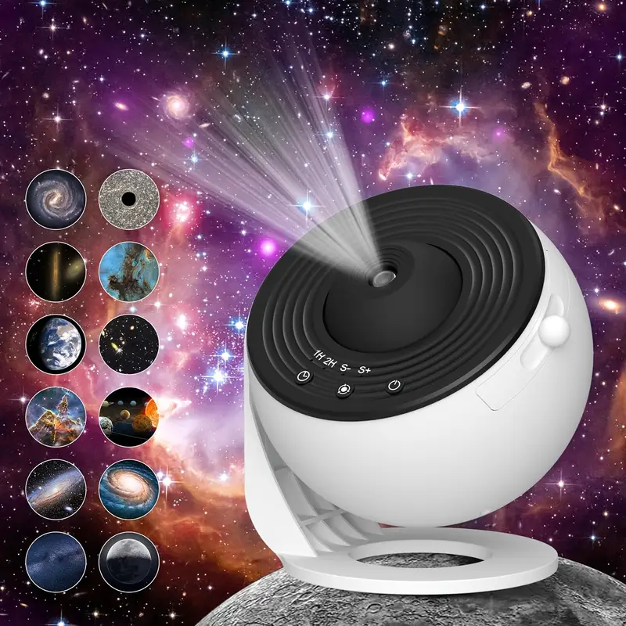

for Galaxy Projection Lamp Night Light Star Planetarium Projection Lamp 360° Rotating Game Room, Home Theater, Ceiling, Room Decoration

$49.00

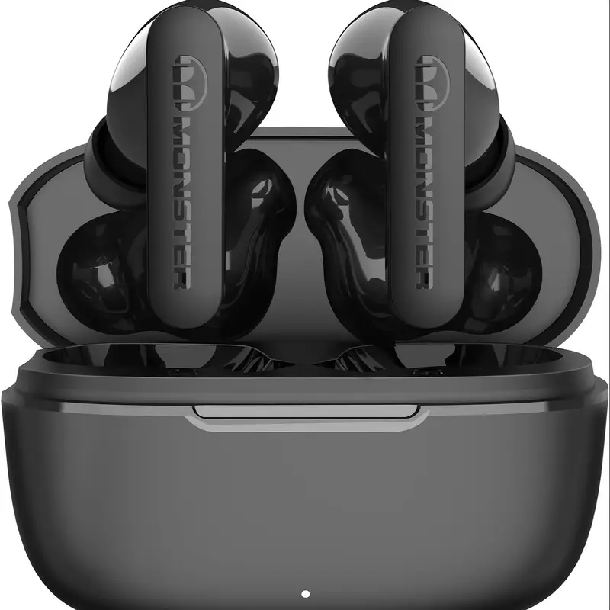

Monster Wireless Earbuds With CVC 8.0 Noise Reduction, Ear Stereo Earphones 60H Playtime, Fast Charging For Sport

$23.20

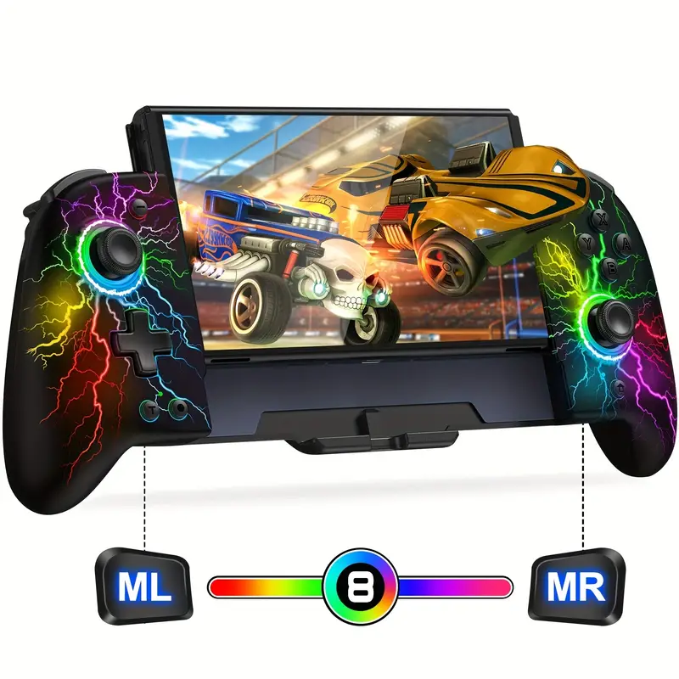

1pc Joypad Controller Replacement For Switch Joy Con - With Adjustable Turbo, Ergonomically Designed - For Nintendo Switch Gamers - Enhance Gaming Experience - Great Gift for Gamers

$52.99

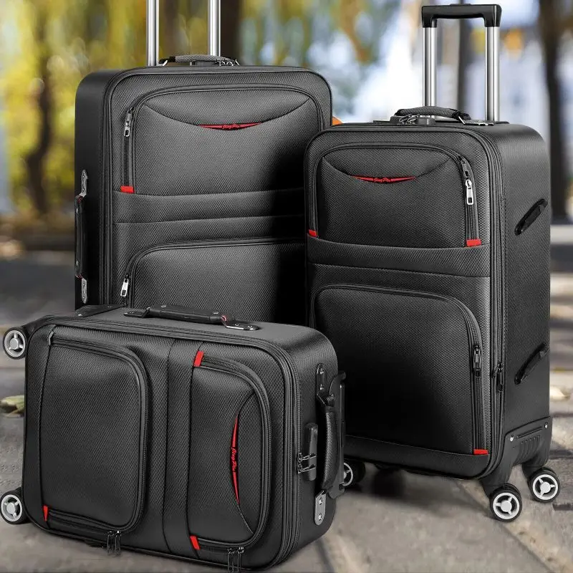

3pcs Softside Expandable Luggage Set with Spinner Wheels, 20in/24in/28in Lightweight Suitcase with Telescoping Handle and Combination Lock, Travel Suitcase Trolley Case, Black/Brown/Purple

$79.65

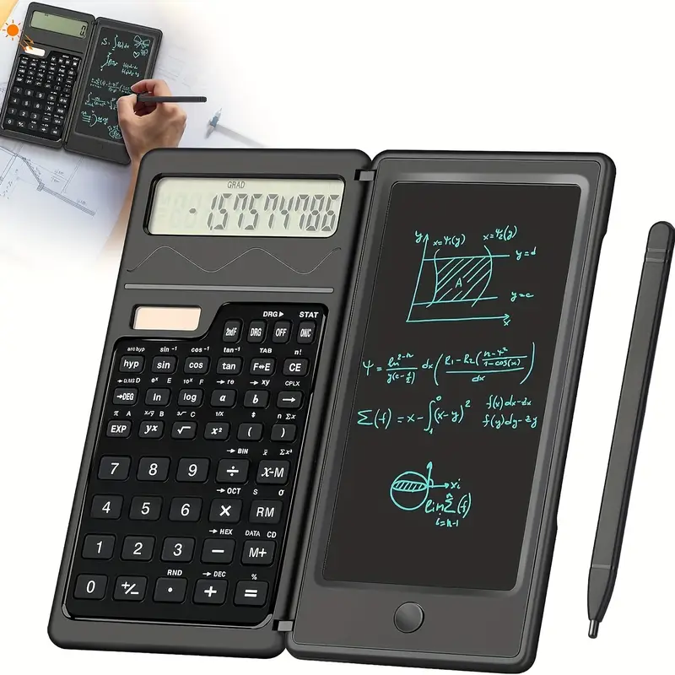

Calculators Ultra-thin Scientific Calculator With 6 Inch Erasable LCD Writing Tablet, 10-Digit Foldable Calculator, Solar Battery Dual Powered - For Students & Teachers - Ideal for Math, Physics, Geometry - Great Gift for Back to School

$10.43





